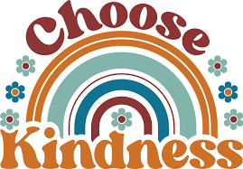AAEC is Celebrating 70 Years of

Serving its Members and Community

Help us share positivity and celebrate **70 Random Acts of Kindness** with a fun giveaway! We are paying it forward to our members by giving away one (1) $70 cash prize each month to a member who has shared their act of kindness with us.   
  
Account # _________________ Member Name _________________________________________________________________________

Tell us about your random act of kindness: ___________________________________________________________________________

________________________________________________________________________________________________________________________  
  
________________________________________________________________________________________________________________________

________________________________________________________________________________________________________________________

***No purchase necessary. The giveaway runs from 3/12/2025-12/31/2025. Open to all AAEC members. No minimum or maximum number of entries. Winners will be randomly drawn. Winners may be announced on our website or social media. All winners will be contacted via phone.***